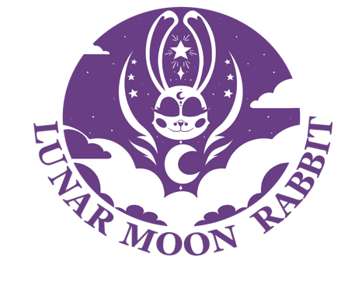
Fatoumata Barry
2D Animator, Character Designer, Storyboard Artist
Creative Design Apprentice

Profile: | Recent college graduate passionate and hungry to put my talent and skills to work. I am an animator, character designer, storyboard artist, illustrator, and a hard worker ready to give you all I’ve got.
Experience: | - 2021- Present  Zack In Time Production — Intern  Background artist and animator for a tv series.
- 2022
Amarok — Final Thesis Film
Animated Thesis Film for Kennesaw State University
(Provide link)

- 2022
Amarok – Art Station Cobb REEL IT IN 2022 Film Festival
Display entry for Final Thesis Film for Kennesaw State University with a runtime of 5 minutes.

Education: | Kennesaw State University, GA USA  BFA - Digital Animation, 2018 – 2022
Skills: | - Toon Boom Harmony  - Storyboard Pro  - Adobe Photoshop  - Adobe Illustration and Krita  - Systems: Mac and PC.  - Character Design  - 2D Animation  - Illustrator
General Interests: | - Animation/ Cartoons  - Comics  - Video Games (Pokémon, Sonic, Shantae...)  - Rabbits  - Merchandise design (logos, stickers, key chains)
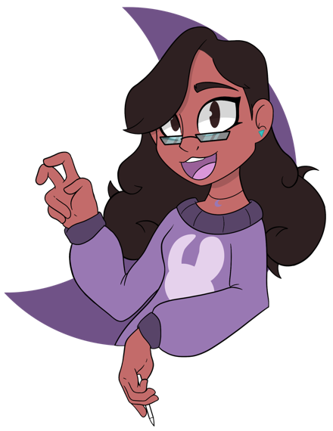
www.lunarmoonrabbit.com
Bintabarry711@gmail.com

